Supplementary Information

Supplementary Fig. 1: Molecular docking simulation of small molecule with MEIOB (aa272-471) and SPATA22(aa236-363).
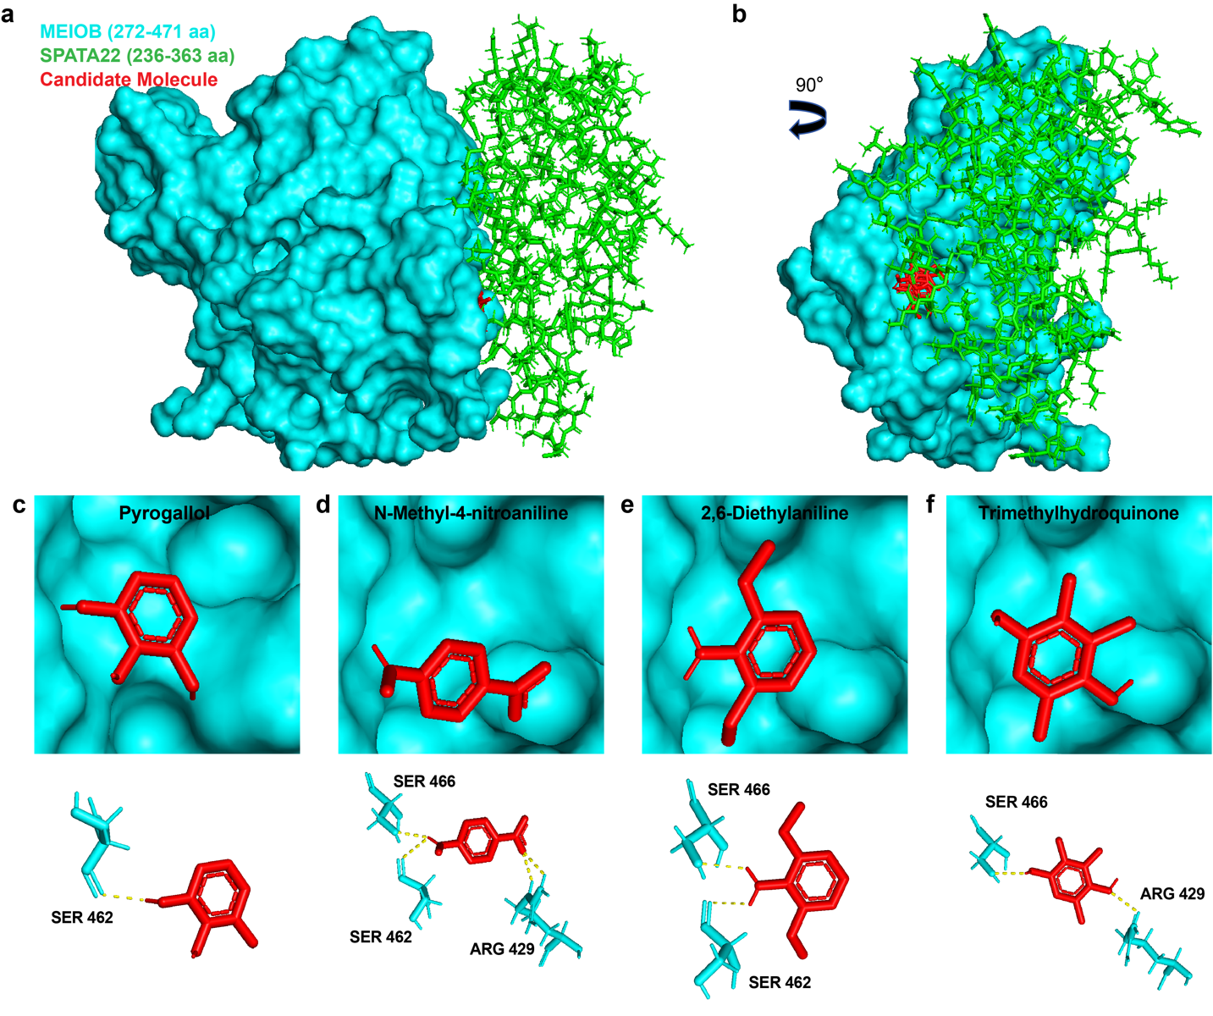

a Preferential binding mode between compounds and MEIOB according to docking simulation using Pymol software. The amino acid residues involved in interactions are labeled. c Preferential binding mode between pyrogallol and MEIOB. d Preferential binding mode between N-methyl-4-nitroaniline and MEIOB. e Preferential binding mode between 2,6-Diethylaniline and MEIOB. f Preferential binding mode between trimethydroquinone and MEIOB. Cyan: MEIOB; Green: SPATA22; Red: Candidate molecules.

